NJ Business Action Center
Storefront and Façade Design Guidelines Template
Purpose
The following template of guidelines may be used to promote quality and appropriate design characteristics and materials use in a mixed-use District for building rehabilitation and new construction. These guidelines reflect best practices in present-day storefront and façade appearance and functionality and would help property and business owners make effective investments as they seek to improve their property’s appearance. They are created with the end user (the property or business owner) in mind. Structured as guidelines, they are not regulatory in nature, unless a District’s municipality chooses to adopt them as part of a zoning overlay, Master Plan or Redevelopment Plan, or a District Management Corporation (DMC) chooses to adopt them and tie them to enhancement projects funded with DMC resources.

New Jersey
Business Action Center

Storefront & Façade Design Standards Template

2023
Introduction
Your business and commercial property has value. As a business or commercial property owner you know that it is very important that all parts of your business and property contribute to your bottom line. From a business plan for how your business can grow, to pleasing merchandising that attracts new customers, to an exciting storefront, every aspect of your or your tenant’s business makes a difference! But as the first point of contact with your business, your or your tenant’s storefront and those of your neighboring business owners define the visible character of the {YOUR} District and as a group should attract new customers and sales. Your storefront image is critical to advertising quality and diversity in both your business and your local commercial district and affects business sales and the value of the property.
Storefronts are highly visible components of any historic, yet eclectic streetscape, with a mix of architectural styles and treatments such as found in the {YOUR} District. Variety adds value and is the key to making your business more noticeable and exciting. While some uniformity may be helpful in reducing overall construction costs, business owners are encouraged to imaginatively explore the relationship of their type of business (i.e. restaurant, bookstore, office, flower shop, etc.) and how that type translates into a unique storefront treatment within your business district. For example, a bakery is clearly not an arts and handcrafts store and is clearly not a travel agency. Their purposes and operations (peak periods, business hours, etc.) are different. They should not all have the same appearance but should look compatible and attractive.
Improving the visual appeal of a storefront can often be accomplished with minor improvements and by removing elements that have been inappropriately added over the years. In some cases, however, renovation may require more extensive work due to lack of proper maintenance or the inappropriate addition of “modern” materials. In either case, an attractive visual presentation is desirable to draw customers to the establishment and increase the likelihood of business success.
The most successful storefronts are those that:
- Work with and leverage the architecture of the larger building
- Simply and clearly market the name of the business and the type of services offered
- Allow potential customers visibility into the store’s well-merchandised interior
- Contribute to a distinctive pedestrian and customer experience; and
- Uniquely enhance the overall business district’s integrity and identity.
Commercial and mixed-use districts such as the {YOUR} District derive much of their identity and brand from both the storefronts, buildings, and the businesses that they contain. The guidelines and recommendations below will help the district and its businesses make the most out of their appearance and become more successful and sustainable economically.

10 TIPS FOR DISTRICT BUSINESSES AND BUILDING OWNERS*
1. LESS IS MORE.
The simpler your design, the better. Too much visual clutter makes it difficult for the passer-by to see your individual business and take notice. One well-placed sign is often the most attention grabbing. Let the historic details of the building speak for themselves.
2. CHOOSE GOOD MATERIALS.
Cheap materials break down quickly and need to be replaced or else your business begins to look shoddy, discouraging shoppers from entering. It is more economical to use quality materials up front and not have to replace them shortly thereafter.
3. MAKE IT EASY TO SEE INTO YOUR STORE.
Let your merchandise and in-store experience speak for itself whenever possible. Too many signs in the window obstruct views that invite customers into stores and make for a more secure environment. Typically, a storefront should have 70% or greater transparency. Never use glass in your storefront that is tinted. Tinted glass makes it hard for anyone walking or driving by to actually see in your business, costing you customers and sales.
4. INCLUDE INVITING LIGHTING.
Think about including inviting lighting when and where possible, both inside the storefront and on the exterior of the building. If done well, lighting draws attention to your business and makes the entire street more enticing.
5. PAINT IS YOUR FRIEND, BUT…
By painting the historic and other details of your building and storefront you will highlight the character of your real estate and market your business. Paint is entirely appropriate for wood surfaces and stucco; however, it is a good practice not to paint over historic bricks and other masonry, particularly on façades. In the {YOUR} district, you are encouraged to use colors for paints that fit your business brand and building element.

6. REMOVING IS OFTEN BETTER THAN ADDING
In many cases, beautiful historic buildings have been covered up by more modern materials. Sometimes simply stripping that covering away reveals beautiful detailing that will draw attention to your store. Likewise, do not cover over the historic materials of the building you have – leave bricks, transoms, and cornices uncovered, for example.
7. KNOW WHO YOU’RE HIRING.
Most work, including awnings and signs, requires a permit from the municipality. Contractors should all be licensed. Choosing a reputable contractor and ensuring that they are aware of the zoning regulations will help you avoid unnecessary fines. Remember that just because someone else on your block has a particular awning or sign, doesn’t mean that it is the best look or even legal.
8. PROPER MAINTENANCE GOES A LONG WAY AND, IN THE END, WILL HELP YOUR BOTTOM LINE.
Keep your windows clean and your signs and awnings in good repair. A fresh coat of paint is a good investment.
9. THINK ABOUT WHAT IT IS THAT MAKES THE {YOUR} DISTRICT UNIQUE.
Complement the distinctive local character of buildings and cultures to create a sense of place that identifies and draws more people to the district.
*Adapted from the NYC Small Business Services: “FAÇADE Guide to Storefront Design”

Photo 1
Together, your storefront’s doors, display windows and transom are called a “storefront system.” Well-maintained storefront systems (see Photo 1) and creative displays are critical to doing good business and to attracting more sales. The system works together as a unit. Therefore, the use of materials, colors and window glazing should be consistent or compatible. They allow those passing by to see your merchandise or service and attract potential customers into your store. Combined with the business’ online presence, this holistic brand experience tells the story of your store, setting expectations of its quality of goods, services, and care that potential customers will receive. You likely have heard the phrase, “That looks like a great place to eat!” or, “That store looks like something I’d want to check out!” Your overall storefront and online brand coordination is what can make the difference in the 5-10 seconds it takes for a customer to walk, bike or drive by your business.

As such, your storefront system is your greatest marketing opportunity so the more storefront windows that people can see through, the better. In general, greater visibility into the store is more inviting and makes potential customers feel more secure and increases the likelihood of them entering the business.

Guidelines for all Elements of Effective Storefront Design in the {YOUR} District
The general guiding principle of excellent storefront design is to keep it simple and to let the natural architectural elements of your building and storefront speak clearly. Storefronts in the are typically one story in height on a building’s first floor and are framed by the existing structure of a larger building that is usually two or three stories tall. A storefront is composed of a series of components that work in unison. Those components are: Windows (display and transom), Window Base, Upper Story Windows, Doors, Commercial Signage, Sign Band or Frieze, Awnings or Canopies, Cornices, Colors, and Lighting. Each of these components will be discussed in detail in the following sections. Not all buildings have all the architectural elements below, but these storefront components should translate to most building types.
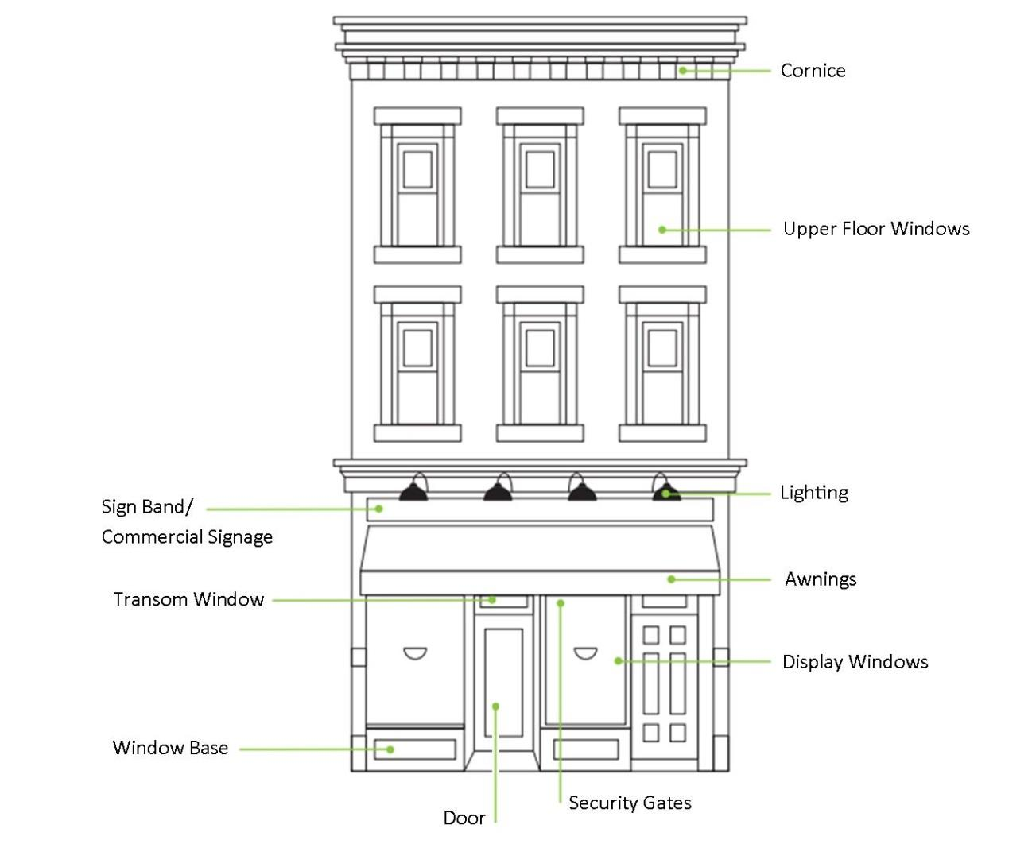
*Image adapted from the NYC Small Business Services: “FAÇADE Guide to Storefront Design” {If the majority of the buildings in your district do not fit this prototype, insert one or more examples of building styles here.}
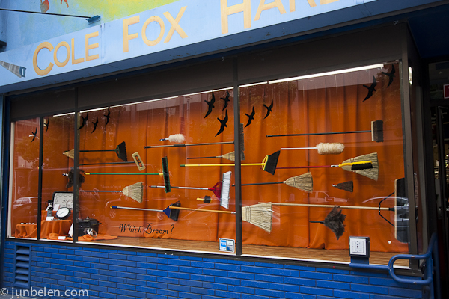
DISPLAY WINDOWS
Display windows (see Photo 2) are the greatest marketing opportunity for a competitive business to attract the attention of those passing by and to generate new sales. Highly successful storefronts use transparent glass that allow potential customers who are walking or riding by to see that the store is open for business and that the business owner is competitively offering quality merchandise. Storefront transparency during both daytime and nighttime hours is critical. Visibility during both periods is important for continuous marketing and branding of the business, as well as promoting a sense of safety in the business district.
Photo 2
Photo 2
Frequently changing displays help to market the variety of goods and services offered in your business while also giving your business and business districts character and interest. The original size, division, and shape of display window areas should be preserved when possible. Creative and thoughtful innovation, however, is desired and strongly encouraged.
Encouraged
- Restoring or increasing the percentage or amount of transparent glass on a storefront. 70- 80% transparency is ideal.
- Replacing dark tinted or textured glass with clear glass when possible to increase visibility into the business and to reduce the need for additional lighting for displays and to show the passersby that the store is actually open.
- Matching new windows to originals.
- Preserving historic features such as frames, special glazing, and decorative moldings.
- Aligning window heights and unifying window sizes when appropriate. Painting window frames to add visual variety and interest.
- Using aluminum or wood frame windows that provide thermal insulation and prevent condensation. Nontraditional colors are encouraged for either frame type.
- Using upper floor windows that might be boarded up as retail display areas.
Strongly Discouraged
- Preventing visibility into display areas by covering, tinting, or blocking a display window.
- Obstructing views into a business by using glass block, woodwork, paint, signage, lowered ceilings, shelves, refrigeration units, cases, posters, or other items except products being temporarily marketed by the business.
- Covering or obscuring existing window trim with metal or other materials.
- Removing historic windows or window components when restoration and maintenance are possible.
- Using fewer durable materials such as Plexiglas.
- Failing to maintain and repair broken or boarded display windows.

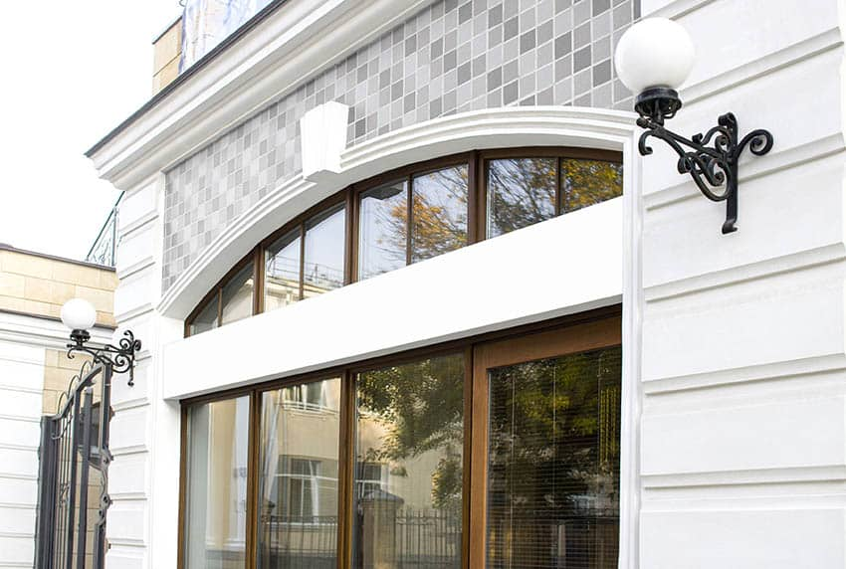
TRANSOM WINDOWS
Transom windows (see Photo 3) are the band of windows above display windows and doors. They provide ventilation and allow daylight deeper into the store’s interior. Sometimes transom windows have been covered by paint or wood to conceal ceiling dropped mechanical systems. Where possible, these windows should be restored to enhance the storefront image.
Photo 3
Encouraged
- Restoring or maintaining the original pattern of transom windows
- Using the same or compatible material and design that are a part of the storefront system. Restoring stained glass panes in transom windows where appropriate and feasible.
- Allowing the transom window to read as a distinctive architectural element by keeping all interior elements at least eight (8) inches behind or away from the transom windows.
- Concealed mechanical systems in a ceiling should be dropped no lower than the height of the display area or windows.
- Restoring and maintaining transom windows even when they will be hidden by awnings as awnings may be removed at some future date.
Strongly Discouraged
- Covering transom windows with paint, signs, awnings or wood panels.
- Filling or covering transom windows with masonry, glass block, wood, ventilation/mechanical systems or other non-transparent materials such as blinds or curtains.
WINDOW BASE
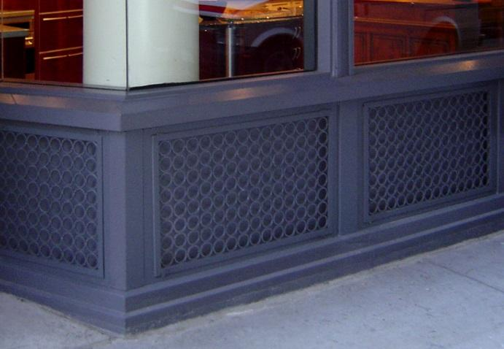
Most storefronts use a window base (see Photo 4) to lift display windows to a more visible level for passersby while protecting display windows from damage and weathering. Window bases are typically made of sturdy, easy-to-maintain materials to counter potential wear and tear. Typical materials include brick, concrete, hardwoods, metal panels, ceramic tiles, and other masonry materials.
Photo 4
Encouraged
Photo 4
- Restoring and/or repairing original, still-in-place window bases.
- Using sturdy, easy-to-maintain window base materials to provide a new and appropriate storefront window base(s). (Sturdy materials include brick, concrete, hardwoods, metal panels, ceramic tiles and other masonry materials.)
- Maintaining or designing window bases for multiple storefronts in a building such that the height (not elevation) of the bases is consistent and the bases are of the same material.
- Installing window bases no higher than two (2) feet (24 inches) from the ground.
Strongly Discouraged
- Eliminating a window base that was a part of the original building or that was also used to conceal any portion of a business’ mechanical systems.
- Varying window base heights within a storefront or building.
- Using non-durable materials, like low-grade plywood, which are not easy to maintain.

UPPER STORY WINDOWS
Upper story windows are the series of windows on the façade above the storefront. They typically are windows to apartments or other residential uses but may also serve office and other non-retail functions. Where possible, these windows should be restored to enhance the building’s image.
Encouraged
- Restoring or maintaining the original pattern of upper story windows.
- Painting the window sashes and trims with accent colors that coordinate with the storefront, cornice and other existing architectural details.
- Restoring stained glass panes in upper story windows where appropriate and feasible.
Strongly Discouraged
- Covering upper story windows with paint, signs, awnings or wood panels, either on the interior or exterior of the windows.
- Filling or covering upper story windows with masonry, glass block, wood, ventilation/mechanical systems or other non-transparent materials.

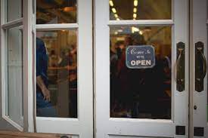
DOORS
Storefront doors (see Photo 5) are best recessed from the storefront wall so that customers are shielded from weather upon entering or leaving your business. The municipality has building codes and accessibility requirements for storefront doors. All new installations must be in compliance with these requirements.
Photo 5
Encouraged
- Restoring or replacing residential-style doors with appropriate commercial doors.
- Installing storefront doors made of non-tinted glass or containing significant clear glass to allow additional visibility into a business.
- Adding new doors when required to meet disabled accessibility laws.
- Maintaining the continuity of storefronts on the primary business street by locating loading and service entrances on the side or rear of a building where possible.
- Installing new and maintaining existing durable wood or metal frame doors that can be painted a variety of colors to emphasize the business entry while adding visual interest.
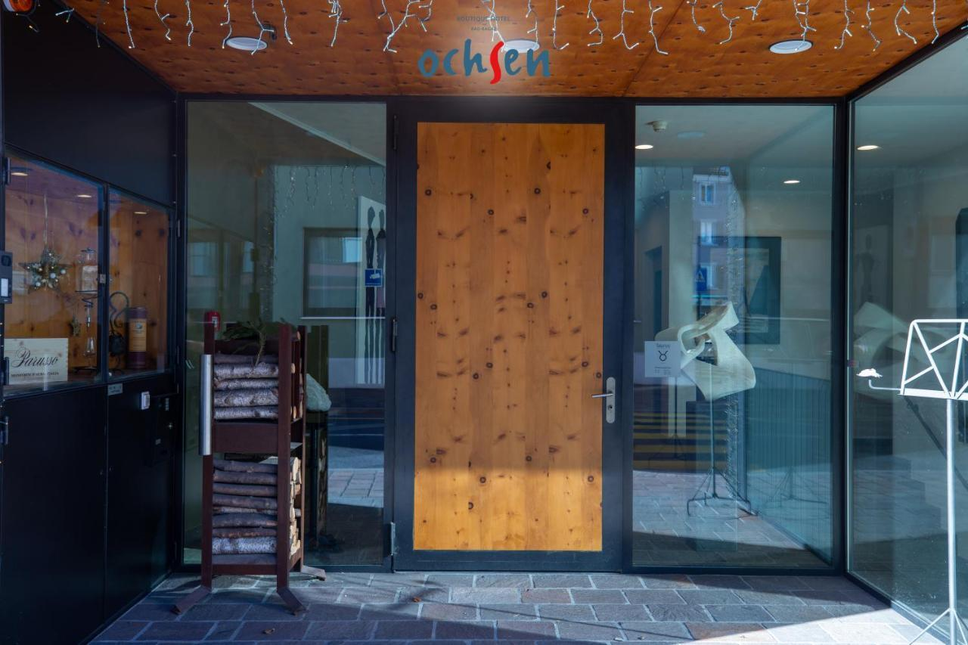
- Installing folding/sliding doors that allow the activity of a business to be opened up to the sidewalk.
Strongly Discouraged
- Adding new doors that are not required by code and which are inconsistent with the building and/or storefront image. Sealing or closing off existing entrances or doorways with any material.
Photo 6
Photo 6
- Blocking doors with merchandise or any other obstruction. Installing doors that swing out directly onto sidewalks.
- Covering or replacing glass door panels with any opaque substance or material that would prevent or limit visibility. (See Photo 6.)
- Covering doorways with signage, interior cases or woodwork.

COMMERCIAL SIGNS
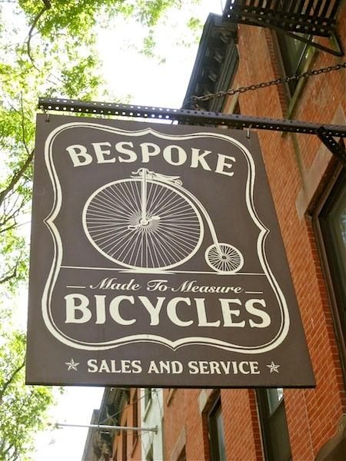
The character of your storefront signage and that of your neighboring businesses contributes tremendously to how your business and your business district are perceived. Beyond windows that allow customers to see what you are offering, signage (see Photos 7 and 8) is by far the most important element of your storefront. Signage makes a strong and dynamic first impression.
Photo 7
Signage can be a creative demonstration of your businesses’ personality and attitude. Businesses that have a lot of signs or signs that are big do not necessarily attract new customers. The more signs that a building has, the more cluttered and confusing the building façade appears.
Photo 7
On average, motorists can perceive only up to four (4) words or symbols on a storefront. The best signs rely on strong graphic character and few words. The best graphic character is achieved when there is a definite contrast between background and text colors. The best location for signs is typically centered over the storefront or the door into the business.
Encouraged
- Replacing, repairing or installing signs that are appropriately scaled for your buildings and storefront.
- Maintaining and restoring historic signs.
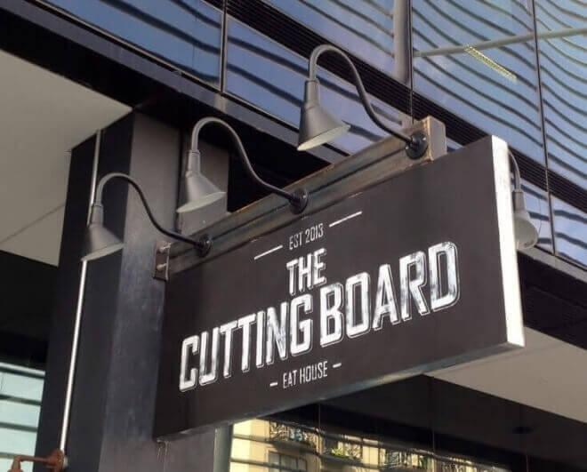
- Exploring very creative graphics and materials that maintain high standards in legibility and character.
- Building flexibility into signage components to allow for changes or upgrades. Installing signs on the frieze or sign band, windows, doors, awnings or other architecturally appropriate location.
Photo 8
- Establishing a sign band on buildings that may not have a clearly demarcated area for signs.
- Using durable wood, painted plastics, metals, or prefabricated pin mounted letters.
- Installing painted metal or wood signs.
- Installing fin or blade signs, projected from the building wall, to identify a business to those passing by walking or traveling parallel to the storefront.
- Exploring bold and vibrant colors that fit with traditional cultural styles of the community, still according to good graphic design practice, is a method of distinguishing a sign while relating the sign to the storefront design and business type or product.
- Painting window signs that act as a secondary signage location or that provide an additional level of information about the business, such as store hours or types of services.
- Recommending three-dimensional, fixed signs that include an icon of the business type or are the business name and/or logo.
- Illuminating signs from above or below. (Backlit box signs are strongly discouraged.)
- Using neon signs, if appropriate to business type, to indicate a business name or trade, but not to advertise products or sales.
- Complying with signage regulations in the municipality’s Sign Code.
Strongly Discouraged
- Applying too many signs to your storefront or building.
- Covering windows, cornices or decorative details with signs or any other element. Blocking visibility into your storefront with signs, shelves or other obstruction.
- Advertising specific branded alcoholic, tobacco or other merchandise in general.
- Installing internally-lit plastic or plastic faced signs. (For example, plastic backlit box or bubble letter signs that are typically seen on highway commercial and large-format retail stores.)
- Maintaining obsolete advertisements or other temporary signs, unless they contribute to the historic character of the district.
- Painting signs directly onto the building surface. (Business-related murals are an excepted.)
- Installing signage above the rooftop.

SIGN BAND
The “frieze” or “sign band” is the portion of the facade that is typically just above the storefront on the first floor and below the second-floor windows or the building cornice on one-story buildings.
Photo 9
The frieze (see Photos 9 and 10) provides an area for building signage and is usually located in a consistent place from storefront to storefront. The frieze should be the first location considered for installing or replacing storefront signage. It should be maintained as a key component of the building design and as the business’ or tenant’s primary means of advertising the name of the business. Care should be taken to reduce the potential of weather damage or bird nesting by placing signs flush against the wall.
Photo 9
Encouraged
- Installing or replacing storefront signage within the original frieze or sign band location.
- Maintaining visibility of the frieze by not covering it with awnings or other additions to the façade or storefront.
- Removing air conditioning, ventilation equipment or other obstruction from the frieze or sign band.
- Using signage to cover A/C units or ventilation equipment or creatively integrating signage with such equipment.
- Integrating external accent lighting adjacent to the sign band area.

Strongly Discouraged
- Covering or concealing the frieze or sign band area of the façade with anything other than an acceptable sign.
Photo 10
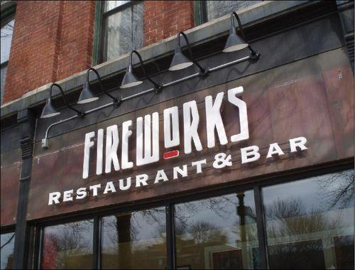
- Installing air conditioning or ventilation equipment in or on top of the frieze or sign band.
AWNINGS
Awnings (see Photos 11 and 12) are canopies made of canvas, metal and other materials and are used to shelter people, merchandise and the display windows. They are typically installed above storefronts, doors and/or windows. Awnings should fit within the overall storefront and building’s organization. Ideally, they should fit within or just over window openings. Awnings are particularly useful in shielding south facing storefronts, outdoor seating areas, and entrances from heavy sunlight exposure. Awnings used on north facing facades are not the best use of funds given the negligible amount of northern sunlight exposure.
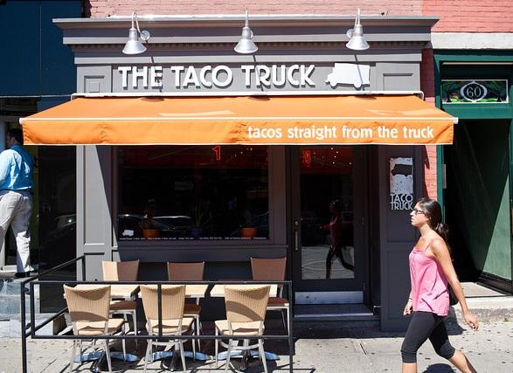
As with signs, excessive use of awnings can significantly reduce the appeal and diversity of storefronts in a building or a business district. Other methods for achieving sunlight control and weather protection, such as blinds or shades, should be explored. This helps to increase visual diversity within a block and/or business district. Awnings can be used to effectively enhance a storefront by adding color, pattern and texture. As with all storefront elements, particular attention should be given to maintaining the awning and information it displays.
Photo 11
Photo 11

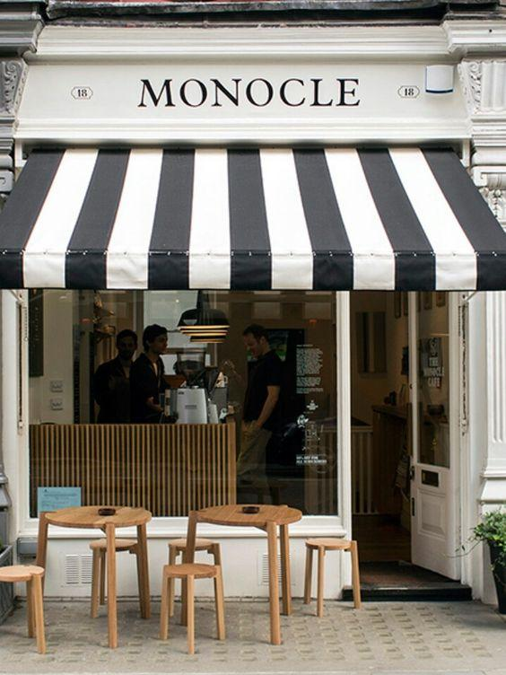
Encouraged
- Installing canvas or metal awnings.
- Using individual awnings for individual storefronts in a building so that the building’s structural frame, detail and rhythm are readable. This also helps to define the extent of an individual store and to establish better business identity.
- Installing retractable or fixed type awnings.
Photo 12
- Illuminating storefronts and sidewalks from beneath an awning.
- Using a consistent size, profile and location for awnings on a single building with multiple storefronts. Font styles may vary from business to business.
- Designing creative awning shapes that are complementary to the overall building.
- Locating signage about the business’ products or service on the valance of the awning.
Strongly Discouraged
- Backlighting or internally illuminating plastic awnings.
- Applying large signage on the sloped portion of an awning. Concealing architectural details including transoms and storefront cornices with awnings or other elements.
- Using a material other than canvas or metal, including vinyl or plastic.
- Using “bubble awnings”. These are effectively signage extensions and do not serve a functional shade or weather protection purpose.
CORNICES
The cornice (see Photo 13) decorates the top of the building and may be made of metal, masonry, or wood. Some decorative cornices project from the building while an ornamental band delineates others. The top of the wall may have a patterned brick band or may have a coping of brick, concrete, or metal. The cornice serves to bring the pedestrian’s eyes back down to the storefront by creating a prominent “limit” to the height of each building. Cornices add distinct character and an aesthetic rhythm to the commercial district. By highlighting cornices and synchronizing them with the storefront the business truly appears to “own” its building.
Photo 13
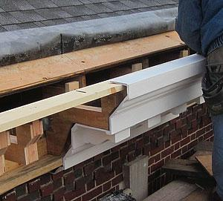
Encouraged
- Maintaining and restoring historic cornices.
- Adding replica cornices (original materials if possible or modern composite to replace wood) if the original is no longer there. (See Photo 14.)
Photo 14
- Using colors that tie into the storefront to highlight the cornice unless it is made from masonry.
Strongly Discouraged
- Removing historic cornices.
- Placing signage or otherwise hiding the existing cornice. Painting masonry cornices that not been painted before.

COLORS
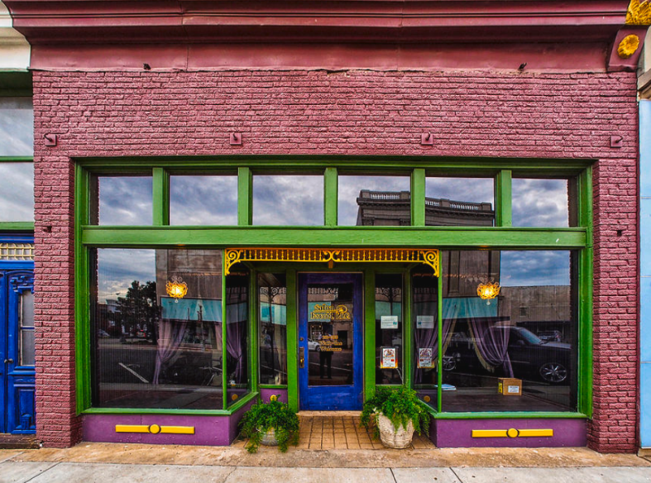
Selection of color is one of the most important improvement decisions that you can make for your business. The color selection ultimately becomes an integral part of your brand and marketing strategy for your business. Your color choice should complement the larger building and that of other businesses within the {YOUR} district. Given the nature of the {YOUR} District, colors may reflect the traditional tones that one would find in a similar setting but allow for flexibility and a vibrant appearance. (See Photo 15.)
Photo 15
The number of different colors used should be kept to a minimum, typically one, three or five, with stronger colors used to highlight architectural and storefront details. Painting masonry that has not been painted before is strongly discouraged. However, for those masonry buildings that have already been painted, a simple change of color is a visual but inexpensive way to dramatically improve the appearance of your business.
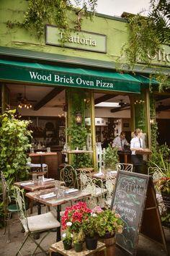
Encouraged
- Selecting paint colors that complement the color of the larger building. (See Photo 16.)
- Using three colors.
- Coordinating the colors of all storefront components as a marketing tool for your business and integrating with the overall business brand, including online presence.
Photo 16
- Using paint colors to accentuate architectural details and storefront elements such as dentils, rosettes, cornice lines, etc.
- Exploring how painting storefronts or buildings in selective locations might increase the visibility of a business without seeming inconsistent or out of character with others in that district.
- Installing pre-painted metal window and door frames and lighting fixtures that fit with your business band and color theme.
Strongly Discouraged
- Painting masonry (particularly brick facades) that has not been painted before.
- Failing to maintain painted or other colored storefront elements that have faded, peeled or flaked due to weather conditions.
- Selecting colors that detract from the overall image of the storefront and building.
- Using more than five colors.
- Using neon or reflective colors unless otherwise allowed by local guidelines and regulations.

LIGHTING
Lighting dramatically enhances your business and storefront appeal. It creates a greater sense of security and can promote your business in the evening hours. Renovations to your storefront could include creative lighting for signage (see Photo 17), display windows (see Photo 18), architectural details, and dark corners/edges of the property or street. Storefront lighting should be carefully coordinated with nearby street lighting.
Photo 17
Encouraged
- Illuminating interior display areas with focused recessed or track lighting to promote merchandise or services inside a business.
- Balancing the amount of building lighting with street lighting.
- Using exterior mounted light fixtures selectively, i.e. sconces or downlights (“gooseneck” lighting) to enhance overall building image.
- Using lighting to illuminate signage or special architectural details. Backlit channel signage (see Photo 17) is one way to add lighting at night while keeping a quality-looking sign for daytime. Sidelit channel signage may also be an option.
Photo 18
- Concealing lighting sources as much as possible when fixtures do not fit the character of the business, building, or storefront.
- Mounting flush LED lights for accents, particularly if solar powered.

Strongly Discouraged
- Backlit box lighting for pedestrian-oriented districts, storefronts, and buildings.
- Frontlit channel signage for pedestrian-oriented districts, storefronts, and buildings.
- Installing flashing, pulsating, or moving lights or lights that cause significant glare except for special occasions, events or a district-wide seasonal lighting program.
- Using fluorescent tubing on either the exterior or interior of the storefront.
- Using neon tubing to border windows, doors and storefronts.
- Using an excessive amount of light fixtures relative to storefront and façade size.
- Installing fixtures that when applied to the building cause too much damage to masonry or other facade material.
- Using non-commercial lighting fixtures.

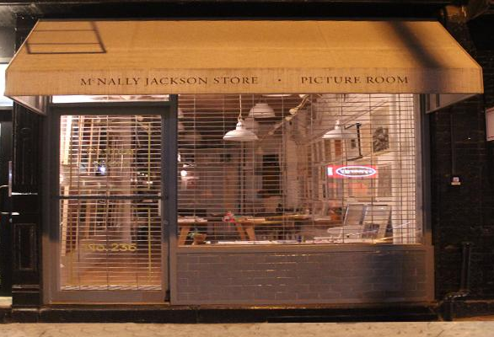
SECURITY SYSTEMS
The security of your business and business district is very important.
However, customers choose to patronize areas in which they feel safe. Safety operates on two levels:
1) The business owner needs to feel that their investment is protected, and 2) the potential customer needs to feel and see that your business district is safe and well managed. For example, metal bars and solid grates detract from an area’s appeal and communicate that crime is a real problem. These systems are also commonly vandalized with graffiti. Perception becomes the reality that can strangle the life and economic vitality from any business district.
Photo 19
Ironically, solid grates make it more difficult for area residents and law enforcement to properly police your business district to prevent theft or other crimes because they cannot see into the businesses. Other options are available to address safety concerns without creating a fortress around your business and the business district.
Transparent windows and doors allow pedestrians and traffic to monitor activities in a well-lit business or district even in the after-hours. There are a variety of glass types (i.e. clear-laminated safety glass, tempered, etc.) that provide additional layers of security, but can sometimes be more expensive. Quality security locks, internal alarms and security systems, and community watch efforts provide additional safety for your business. Open wire-mesh grates (Photo 19) have gained a great deal of popularity lately because they keep burglars out while allowing potential customers and the police to see inside the business at night. Open wire-meshes are best built into the interior of the storefront ceiling where their mechanical systems are concealed. In such cases where these physical measures are needed, this style of grate is strongly recommended, however the best practice is to not install (or to remove) grates in most settings.

Encouraged
- Removal of exterior roll-down grates.
- Replacing exterior roll-down grates and grate boxes with open wire-mesh type security grates with a minimum of 70% transparency.
  - Wire mesh grates must have the grate box or mechanical unit installed into the interior ceiling of the display window.
  - Vertical and horizontal guide tracks should be installed parallel to display window’s vertical and horizontal framing elements.
  - Colors for all roll-down elements should be painted or purchased as black or brown to decrease their visibility so that passers-by will focus on the products or services in your business. Where possible, if grates are needed and permitted, exterior wire-mesh grates should be built into the storefront itself.
- Replacing old single-pane storefront windows with clear laminated safety glass.
- Installing an electronic alarm system that automatically notifies the police and the business owner.
- Using ornamental gates to secure entry areas in front of storefront doors.
- Concealing existing grate systems with an awning only when circumstances would make removal of the grate prohibitive.
Strongly Discouraged
- Installing a solid roll-down grate.
- Maintaining non-retractable security bars on the exterior of windows and doors.
- Replacing or covering glass, display windows and doors with Plexiglas or any other material that is not truly clear and translucent.
Photo Credits
Photo 1: https://www.pymnts.com/smbs/2017/main-street-usa-winning-again-store-front-smb-fitness industry/
Photo 2: https://tenleytownmainstreet.org/news/storefront-spruce-up/
Photo 3: https://designingidea.com/transom-windows/
Photo 5: http://h-town-visually.blogspot.com/2013/05/okra-charity-bar.html
Photo 6: https://hotel-restaurant-ochsen-bad-ragaz.booked.net/
Photo 7: http://www.davessigns.com/blade-signs-gallery-ventura-santa-barbara-los-angeles-county.html
Photo 8: https://www.barnlight.com.au/the-cutting-board-sma-design-gooseneck-lights-rustic-sconces lend-warehouse-look-to-new-eatery/
Photo 9: https://bigmouthsigns.com/retro-storefront-signs-in-atlanta-ga-for-the-cupcake-people/
Photo 10: http://keenesignworx.typepad.com/sign_talk/design/page/2/
Photo 11: http://hmag.com/ay-dios-mio-taco-truck-closing-briefly-renovations/
Photo 12: http://primadonna.co.vu/post/56918211428
Photo 13: www.americancarriagebuilder.blogspot.com200906dont-blog-and-drive.html
Photo 14: http://www.bbsheetmetal.com/wp-content/uploads/2015/09/Crest-Cornice.jpg
Photo 15: https://fineartamerica.com/featured/colorful-storefront-buck-buchanan.html
Photo 16: http://www.fairweathermag.com/food/2016/11/11/olio-e-piu
Photo 17: https://gallery.businesssigns.net/shanghai/the-cool-docks/painted-stainless-steel-led-backlit-restaurant-signs.html
Photo 18: https://unsplash.com/photos/q6zV1ioOel4
Photo 19: https://www.nygates.com/products/rolling-grilles/

